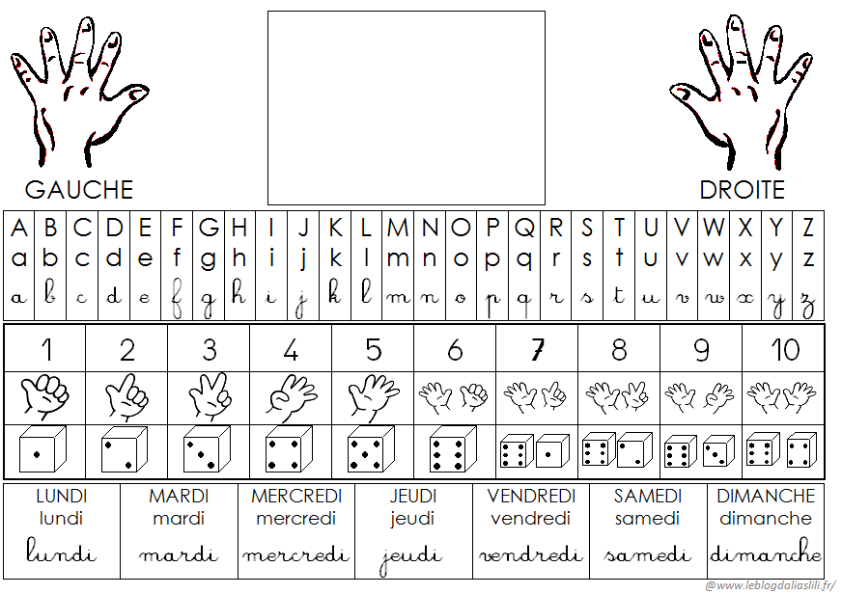

# CHARLOTTE

# Charlotte

Charlotte