[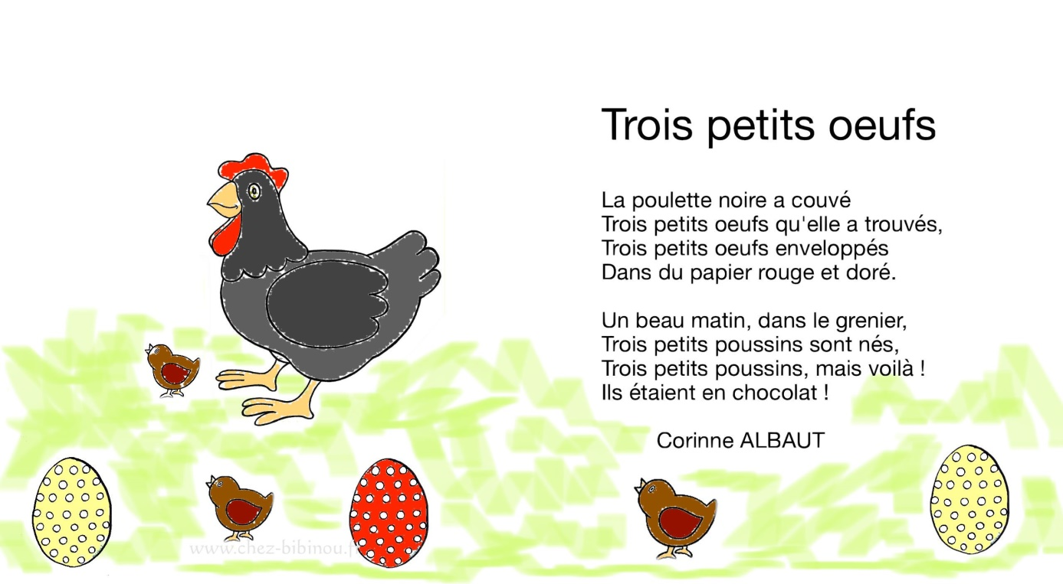](https://www.google.com/url?sa=i&url=https%3A%2F%2Fwww.chez-bibinou.fr%2Ftrois-petits-oeufs%2F&psig=AOvVaw3MG7nwddj1WzHN0RQL7w4J&ust=1586307772544000&source=images&cd=vfe&ved=0CAIQjRxqFwoTCMiXlo2P1egCFQAAAAAdAAAAABAD)