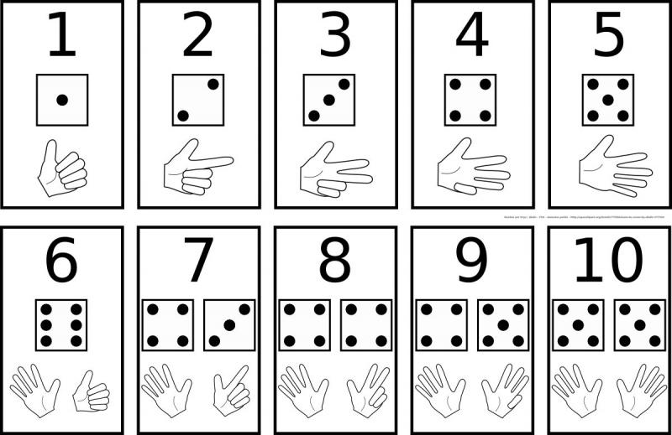Prénom

Date

Nombres : colle 7 images

|  |  |  |  |  |  |
| --- | --- | --- | --- | --- | --- |
|  |  |  |  |  |  |
|  |  |  |  |  |  |
|  |  |  |  |  |  |
|  |  |  |  |  |  |

