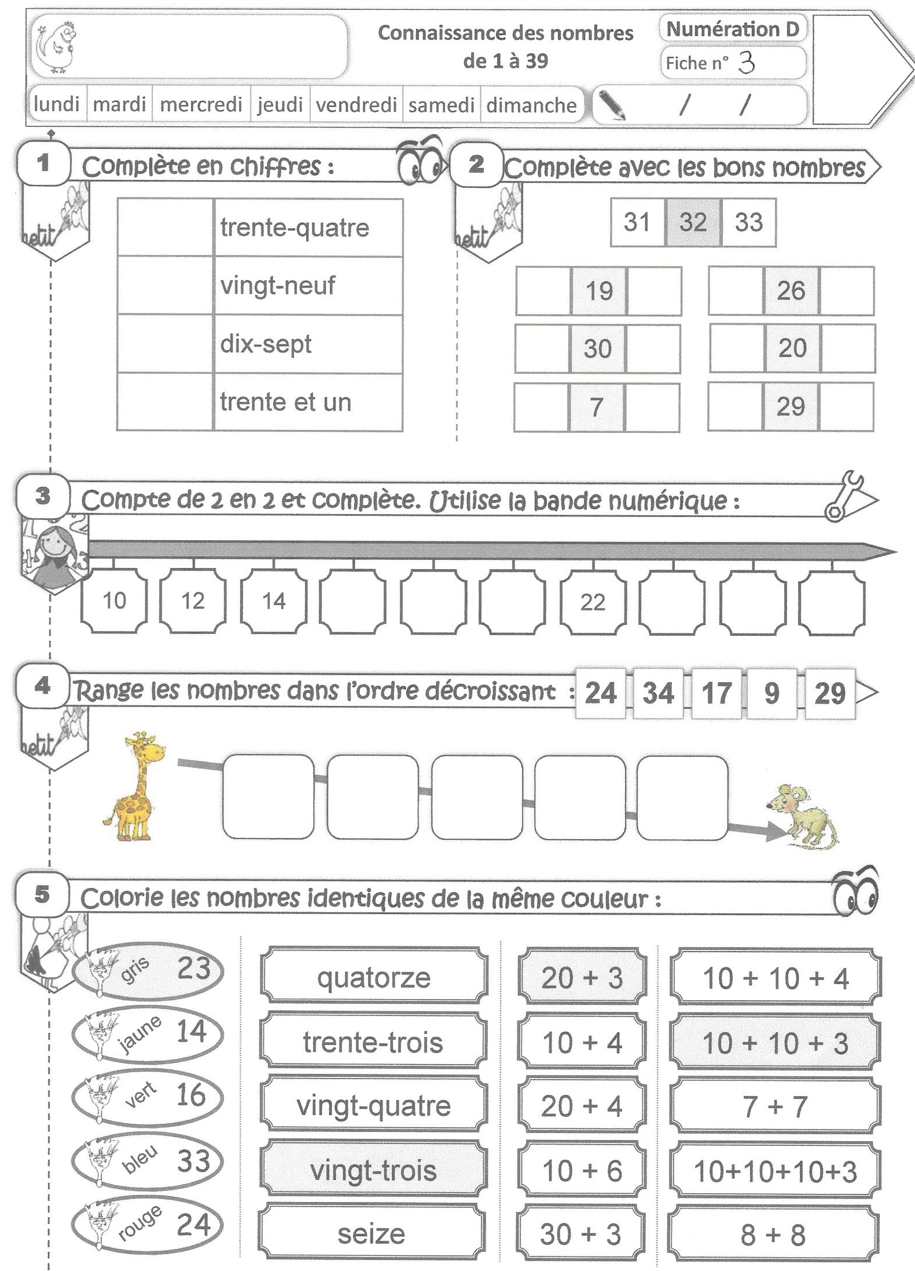

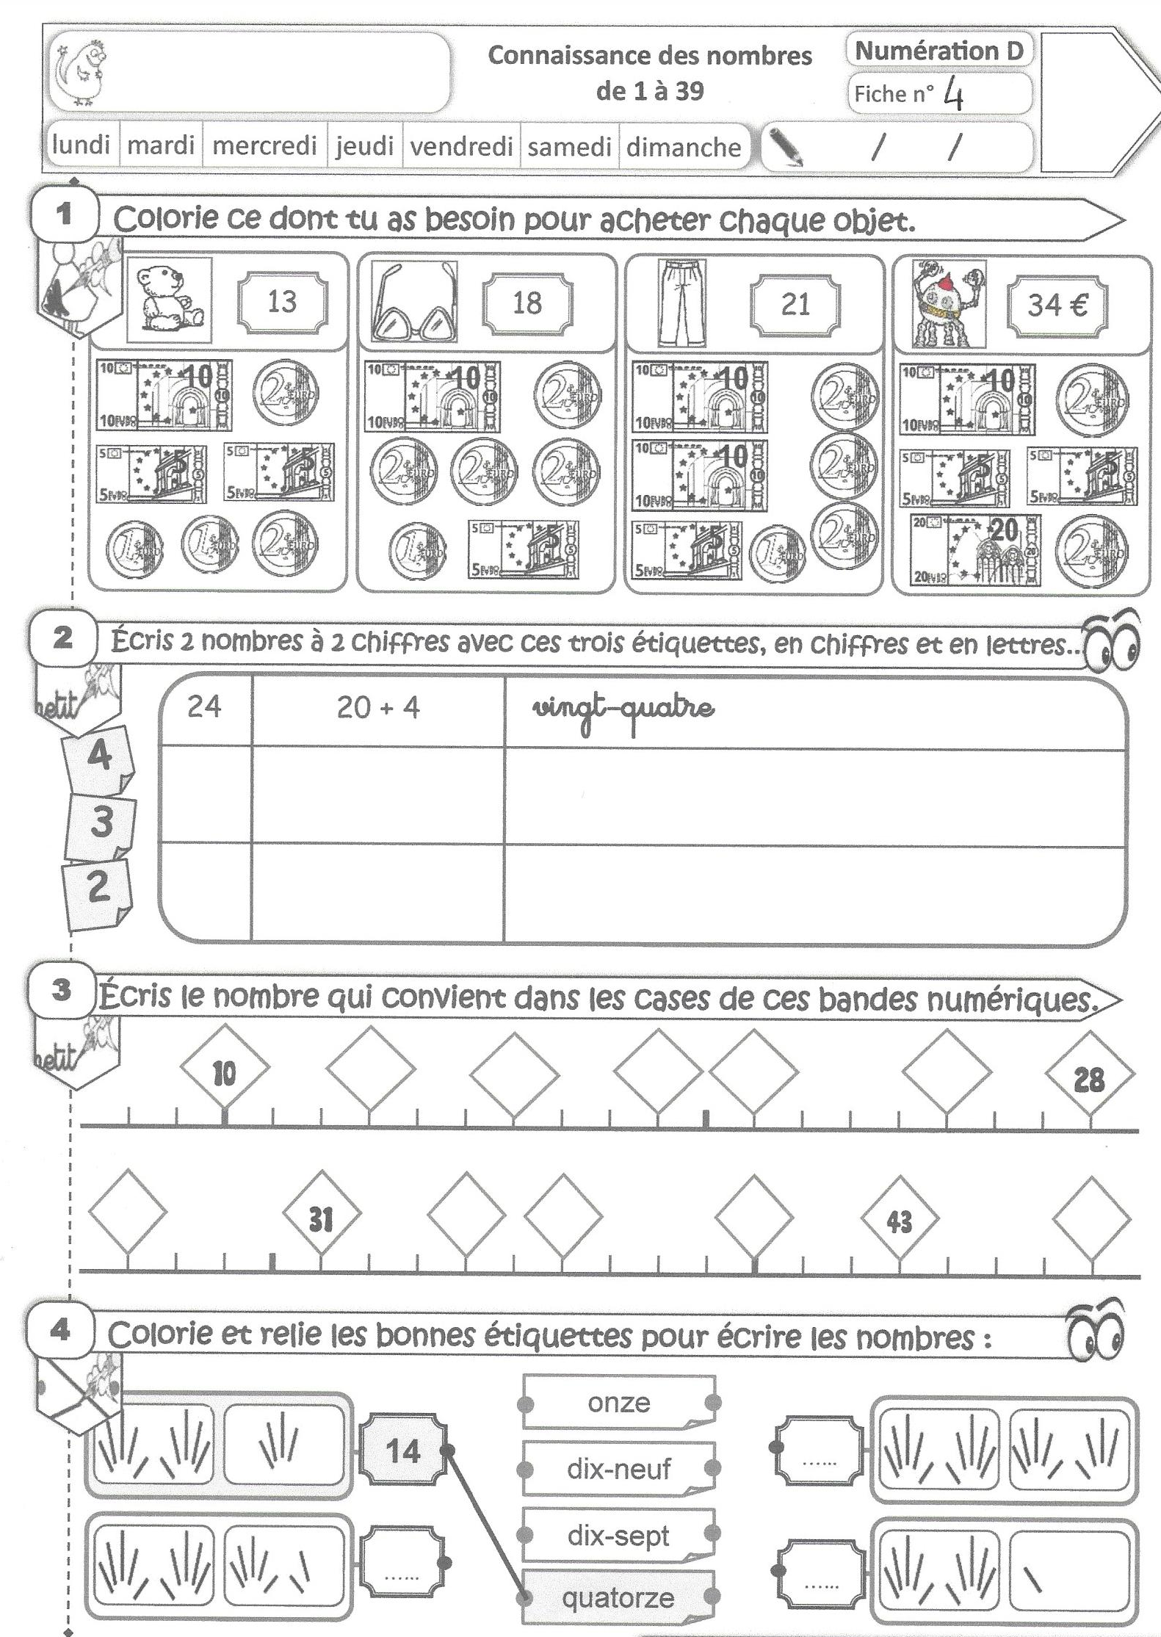

Fiche de calculs : Addition et soustraction de 2 nombres
9 - 6 =__________ | 15 - 5 =__________
14 - 7 =__________ | 10 + 8 =__________
11 + 5 =__________ | 15 - 9 =__________
13 - 6 =__________ | 15 - 7 =__________
5 + 5 =__________ | 10 - 9 =__________
9 + 7 =__________ | 9 + 5 =__________
14 + 8 =__________ | 9 - 1 =__________
11 + 10 =__________ | 15 - 8 =__________
11 - 5 =__________ | 12 - 8 =__________
15 - 4 =__________ | 5 - 5 =__________
14 - 5 =__________ | 6 - 5 =__________
14 - 6 =__________ | 15 - 3 =__________

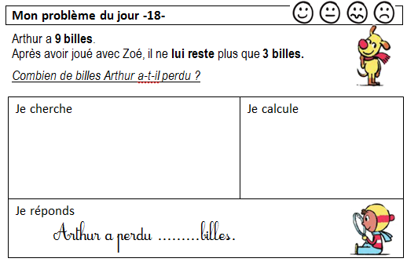

Revoir l’écriture de quarante.

