**Labysons du k, qu, c**

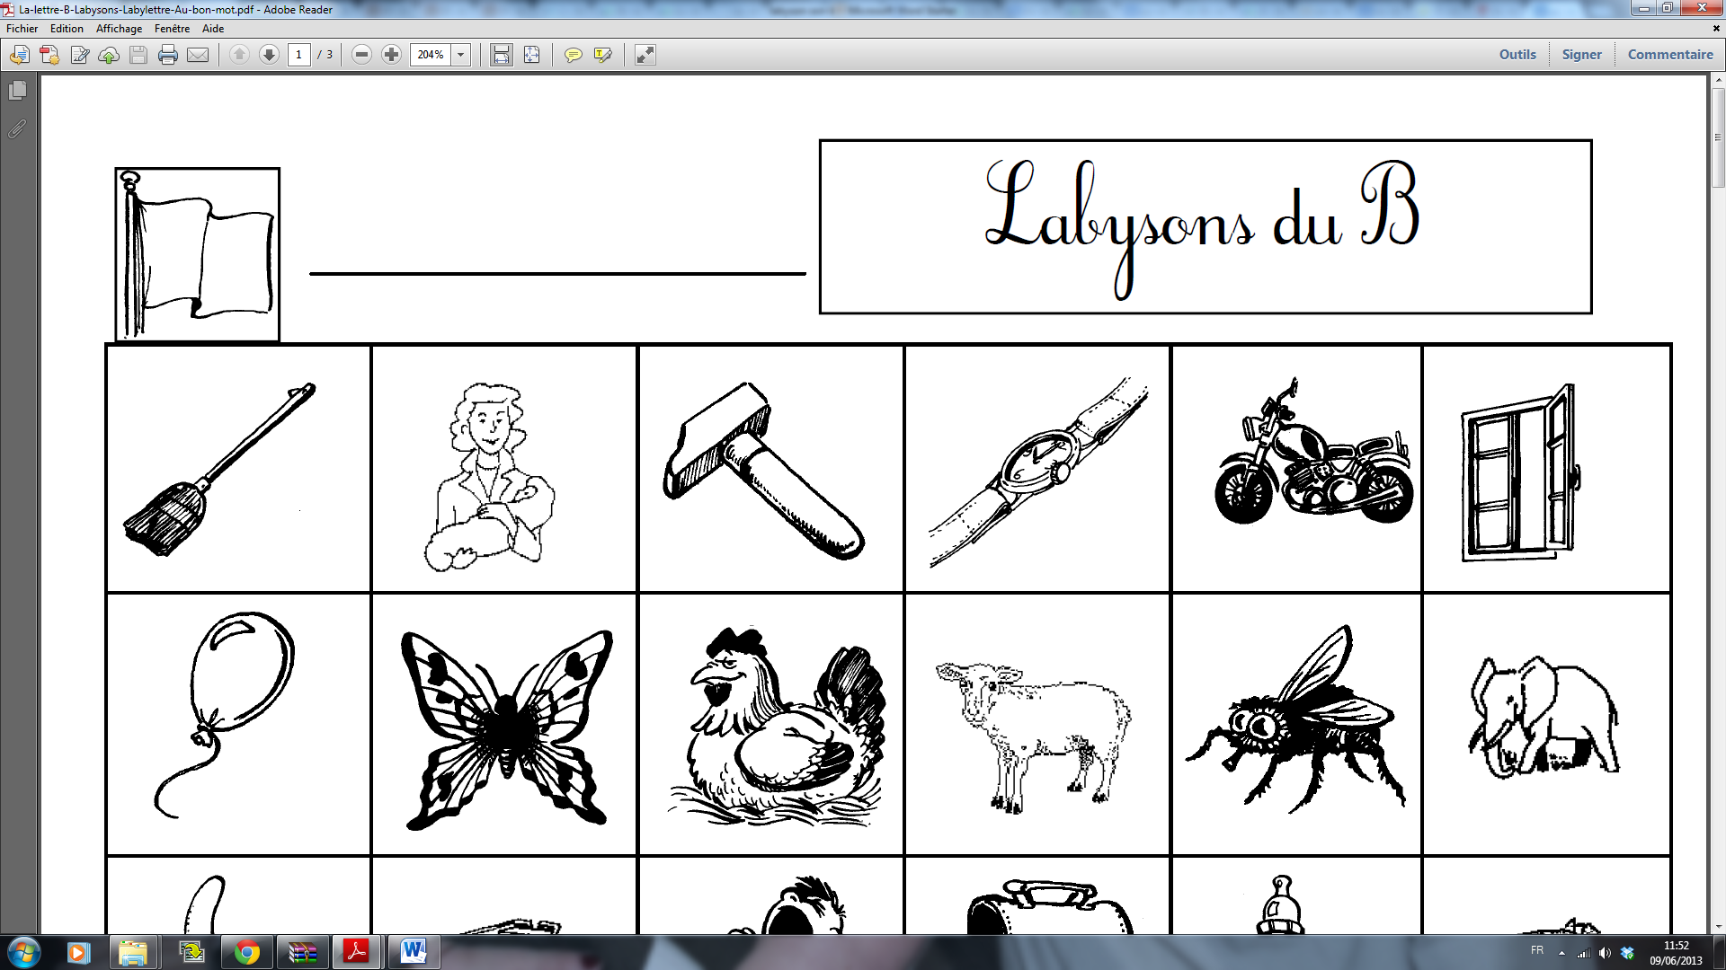

|  |  |  |  |  |
| --- | --- | --- | --- | --- |
|  |  |  | https://encrypted-tbn3.gstatic.com/images?q=tbn:ANd9GcTQ296DA39bjamoNkvcqB2AljFdUsRga2sDPDn3mwppcdbNGk2kiQ | http://fauneetflore.haplosciences.com/baleine.gif |
| http://idata.over-blog.com/1/88/97/82/Mes-astuces/confiture.gif | http://www.phonemus.fr/images/bibliotheque/banc.gif | http://www.phonemus.fr/images/bibliotheque/ciseaux.gif | http://www.phonemus.fr/images/bibliotheque/gourde.gif | http://www.phonemus.fr/images/bibliotheque/manger.gif |
|  | https://encrypted-tbn1.gstatic.com/images?q=tbn:ANd9GcQqRINupgnygIcjaeC7Z9RnuEcoUXYdJxdnDikswBdxi9w8kn4E |  | https://encrypted-tbn2.gstatic.com/images?q=tbn:ANd9GcQhV7Xk_iY_YsAw8VagtprT_hkYw7DnyoVYIxPmolSmr8xaj9DQ | http://www.phonemus.fr/images/bibliotheque/panda.gif |
| http://www.phonemus.fr/images/bibliotheque/pelle.gif |  | http://www.phonemus.fr/images/bibliotheque/grenouille.gif | http://environnement.ecoles.free.fr/Coloriages_dessins/images/carte-a-jouer-as-de-coeur.JPG | http://www.phonemus.fr/images/bibliotheque/sifflet.gif |
| https://encrypted-tbn3.gstatic.com/images?q=tbn:ANd9GcTXxmr3LPCUNOJYFJgDYRd651orm464aqsv6qS56ZG8XGXNe-RV | https://encrypted-tbn1.gstatic.com/images?q=tbn:ANd9GcTL3Zc4zEMUTQ_WQ7Lc_xglk7oui2xEA_IqOFHNlziAVKXFxZQzIQ | https://encrypted-tbn2.gstatic.com/images?q=tbn:ANd9GcRc4TpdW8yMijNGEW_T3veb7v74f2Q4jkNwCJ8pFElr1C2sWmwvWw | http://www.dessin.tv/files/2011/11/coloriage-escargot.jpg |  |
| http://www.mescoloriages.com/coloriages/animaux/dans%20la%20mer/requins/images/requins_006.gif | http://www.coloriages.fr/coloriages/coloriage-champignon.jpg | http://lol.net/coloriage/coloriage/mini/coloriage-chaussure.jpg | https://encrypted-tbn3.gstatic.com/images?q=tbn:ANd9GcSjLaOc0by6__ucvLiaOVkScAcYSQJIGWxlNcYep7EGokZfpwHw | https://encrypted-tbn2.gstatic.com/images?q=tbn:ANd9GcSzwzH3gBYlxTJPbC65bep63xd8xusfG-EjT8MEovyis0JTrUmOyg |
| http://coloriages.dessins.free.fr/images/coq.JPG | coloriage de: dessin,chocolat,plaquette,chocolatee,carre | https://encrypted-tbn2.gstatic.com/images?q=tbn:ANd9GcTFlQ75oowhdDY-0WiVirPk6OAgIV19j28xemiBO_SUASM1iJ4d5Q | https://encrypted-tbn2.gstatic.com/images?q=tbn:ANd9GcT-JOwlzI7jLOOA_uyVEN_4xsvqxYNNw191LtRG16dWz8bEZTmd |  |